Wishing For Warmth
RULES: Practical Shooting Competition League rulebook, Latest Edition COURSE DESIGNER: Mike Shelton
START POSITION: Feet touching start stick with rifle loaded and safety engaged.

STAGE PROCEDURE  Upon audible signal, engage targets as they become visible from within the shooting area. | SCORING  SCORING: Comstock, 34 rounds, 170 points  TARGETS: 17 paper  SCORED HITS: 2 Best hits per target  START-STOP: Audible - Last shot  PENALTIES: Per the PCSL rulebook
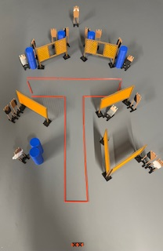
SETUP NOTES:. |  | RO NOTES:

